**DAILY ONLINE ACTIVITIES SUMMARY**

|  |  |  |  |  |  |  |  |
| --- | --- | --- | --- | --- | --- | --- | --- |
| **Date:** | **13/06/2020** | | | | **Name:** | **Sheetal** | |
| **Sem & Sec** | **8 B** | | | | **USN:** | **4AL16CS091** | |
| **Online Test Summary** | | | | | | | |
| **Subject** | | **IOT** | | | | | |
| **Max. Marks** | | **30** | | **Score** | | **29** | |
| **Certification Course Summary** | | | | | | | |
| **Course** | **Hadoop: Master your Big Data** | | | | | | |
| **Certificate Provider** | | | **Great learning** | **Duration** | | | **2 hr** |
| **Coding Challenges** | | | | | | | |
| **Problem Statement:**  **1) Python program to display calendar** | | | | | | | |
| **Status:completed** | | | | | | | |
| **Uploaded the report in Github** | | | | **Yes** | | | |
| **If yes Repository name** | | | | [alvas-education-foundation](https://github.com/alvas-education-foundation)/ **[sheetal-shettigar](https://github.com/alvas-education-foundation/sheetal-shettigar)** | | | |
| **Uploaded the report in slack** | | | | **Yes** | | | |

ONLINE TEST

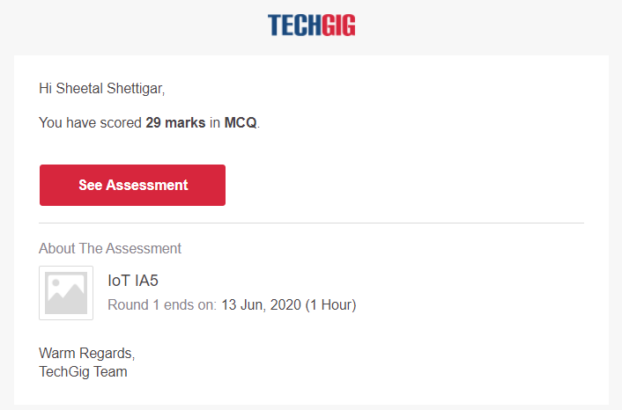

CERTIFICATION:

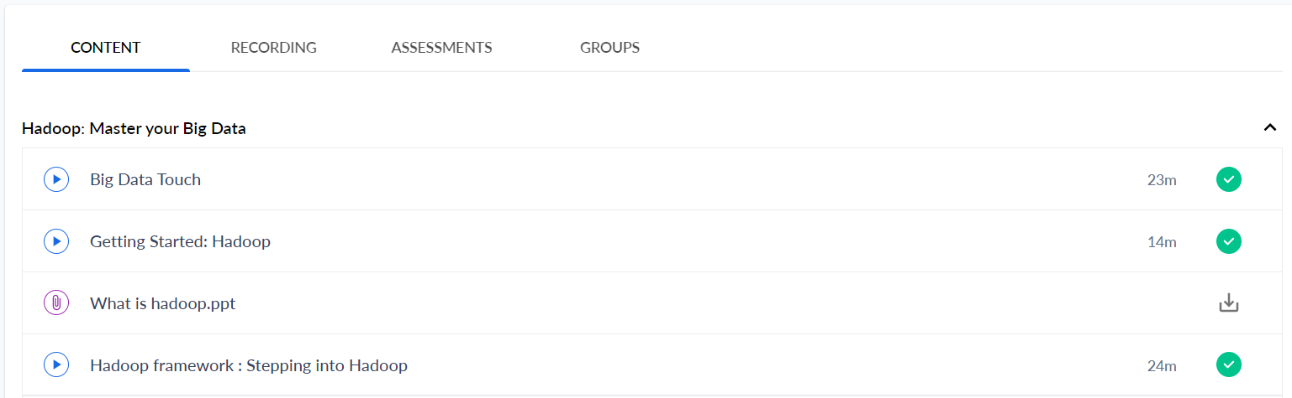

CODING CHALLENGE:

PROGRAM 1 :

import calendar

yy = 2014 # year

mm = 11 # month

# To take month and year input from the user

# yy = int(input("Enter year: "))

# mm = int(input("Enter month: "))

# display the calendar

print(calendar.month(yy, mm))